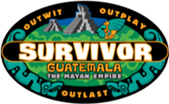

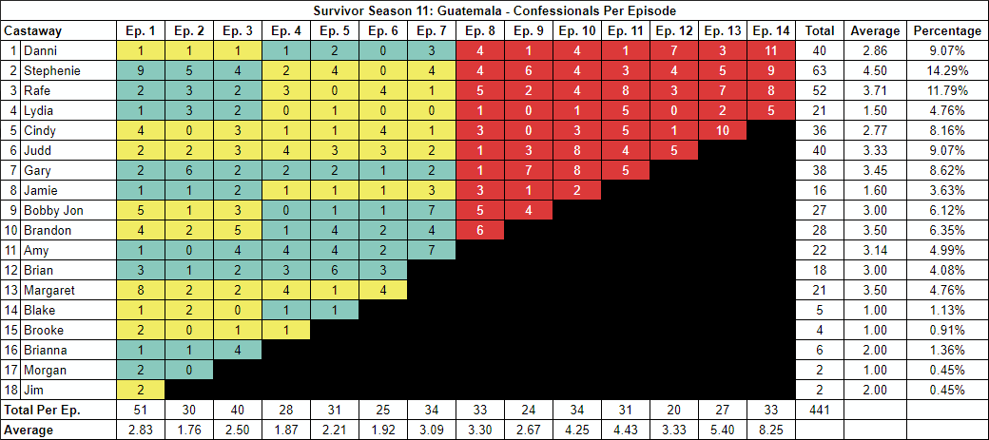

**Survivor 11x01: Big Trek, Big Trouble, Big Surprise**

**Survivor 11x02: Man Down**

**Survivor 11x03: The Brave May Not Live Long, But the Cautious Don't Live at All**

**Survivor 11x04: To Betray or Not to Betray**

**Survivor 11x05: Crocs, Cowboys and City Slickers**

**Survivor 11x06: Big Ball, Big Mouth, Big Trouble**

**Survivor 11x07: Surprise Enemy Visit**

**Survivor 11x08: The Hidden Immunity Idol**

**Survivor 11x09: Secrets and Lies and an Idol Surprise**

**Survivor 11x10: Eating and Sleeping With the Enemy**

**Survivor 11x11: Everything Is Personal**

**Survivor 11x12: Price For Immunity**

**Survivor 11x13: Big Win, Big Decision, Big Mistake?**

**Survivor 11x14: Thunder Storms and Sacrifice**